STM JOURNALS

Template
of
STM Journals
and
Journals Pub

STM JOURNALS

Title of the STM Journals
http://stmjournals.com/journals-index.html
ISSN: 2278-2257 (Online)
ISSN: 2348-9553 (Print)
Volume 10, Issue 1, 2021 DOI (Journal): 10.37591/ABBREV

Type of Article ABBREVIATION

Title of the Article

First Author Full Name^{1,*}, Second Author Full Name², Third Author Full Name¹, Fourth Author Full Name³

Abstract
An abstract is a brief summary of a main manuscript. It should be written in ~300 words. The abstract should be written concisely and clearly without any abbreviations, references, or citation. The abstract should be well written and is grammatically correct.

Keywords: There should be five to ten keywords or phrases each separated by a comma

INTRODUCTION
Manuscript should be submitted in .doc, .docx, .rtf files. Manuscript should be around 2000 to 7000 word count [1]. Please do not use MS Word older than the 2010 version. Use only Microsoft Office 2010 or later versions. The main text of the manuscript should appear here with headings as appropriate. Author should mention the type of manuscript on the top of manuscript (research article, review article, case study, popular article, or any other type of article).

Authorship should be carefully listed in a correct order of authors before submitting the manuscript. Author can made addition, deletion, or rearrangement of author names in the authorship list only before the manuscript has been accepted.

Introduce the article properly in paragraphs separated by headings, subheadings, images, and formulae. To avoid errors in the article, author is advised to use the ‘spellchecker’ function of MS Word. Authors are responsible for obtaining permission from copyright holders for reproducing any illustrations, tables, figures, or lengthy quotations previously published elsewhere.

Article should be written in following order: Title of the Article, Authors, Affiliations, Abstract, Keywords, Main text (including figures and tables), Conflicts of Interest, Ethics Approval,
Acknowledgements, Abbreviations and Nomenclature, References, Appendix. Author should not use
footnote or endnote for the citation in the article.
*Author for Correspondence
Corresponding Author Full Name
E-mail: baedfcvbgsayana@gmail.com

¹Affiliation and complete postal addresses of affiliated organization all authors (e.g., Affiliation, Name of Affiliated Organization, Name of Department/School/Faculty/Research Group, Name of University/Institution/College, City, State/Province, Country)
²Lecturer, Department of Pharmacy, College of Medical and Health Science, Bule Hora University, Bule Hora, Ethiopia ³Assistant Lecturer, Department of Veterinary Pharmacy, Gondar University, Gondar, Ethiopia

Received Date: Month Date, Year Accepted Date: Month Date, Year Published Date: Month Date, Year

Citation: First Author, Second Author, Third Author, Fourth Author. Title of Article. Title of the STM Journals. Year; volume(issue): 1–5p.

HIERARCHY OR LEVEL OF HEADING
Author can use headings, subheadings to present the work in the following ways.

LEVEL 1 OR H1 HEADING: PHILOSOPHICAL APPROACHES
Bryman [2] asserts that there are different views about the scope, range, ordering, and labelling of philosophical approaches.

Level 2 or H2 Heading: Philosophical Approaches
Bryman [3] asserts that there are different views about the scope, range, ordering, and labelling of philosophical approaches.

Short title of article should not be more than 60 characters (including space) Short Author

Level 3 or H3 Heading: Philosophical Approaches
Bryman [4] asserts that there are different views about the scope, range, ordering, and labelling of philosophical approaches.

Level 4 or H4 Heading: Philosophical Approaches
Bryman [5] asserts that there are different views about the scope, range, ordering, and labelling of philosophical approaches.

Level 5 or H5 Heading: Philosophical approaches (H5): Bryman [6] asserts that there are different views about the scope, range, ordering, and labelling of philosophical approaches.

Level 6 or H6 Heading: Philosophical approaches: Bryman [7] asserts that there are different views about the scope, range, ordering, and labelling of philosophical approaches.

TABLES AND FIGURES
Authors should submit tables as editable text and not as images. Tables should be numbered (with Arabic numerals as Table 1, Table 2, etc.) and referred to by number in the text. Tables can be placed either next to the relevant text in the article, or on separate page(s) at the end. The captions for the Tables should be provided separated from the text. All Figures and Tables should be numbered and cited. Source of all Figures should be provided.

For all Tables, use the following symbols in order as footnotes: * (asterisk), † (dagger), ‡ (double dagger), ¶ (paragraph mark), § (section mark), ‖ (parallels), **, ††, ‡‡, etc.

Authors should submit Figures as per “Artwork Guidelines”. Figures are to be numbered in one consecutive series of Arabic numerals in the order in which they are cited in the text. The captions for illustrations and figures should be separated from the text and collated in a separate section called “Legend to Figures.” Tables and Figures should be self-explanatory.
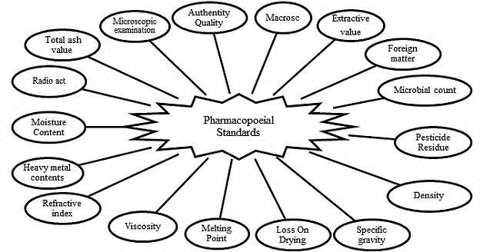
Figure 1. Figures should their Captions.

Artwork Guidelines
Illustrations, pictures, and graphs should be with the highest quality, and text in the illustrations, pictures and graphs should be readable. Following guidelines enable us to prepare your artwork for the printed issue as well as the online version.

Title of the STM Journals Volume 10, Issue 1
ISSN: 2278-2257 (Online), ISSN: 2348-9553 (Print)

Placement: Figures/charts and tables created in MS Word should be included in the main text. Figures and other files created outside Word (i.e., Excel, PowerPoint, JPG, TIFF, EPS, and PDF) should be submitted separately. Please add a callout in the running text (i.e., insert Figure 1).

Resolution: Rasterized based files (i.e., with .tiff or .jpeg extension) require a resolution of at least 300 dpi (dots per inch). Line art should be supplied with a minimum resolution of 800 dpi.

UNITS OF MEASUREMENT
Authors should follow internationally accepted rules and conventions. Units should be expressed in the international system of units (SI). If other units are mentioned, please give their equivalent in SI.

ABBREVIATIONS AND NOMENCLATURE
Except for units of measurement, abbreviations, and nomenclature when it appears for the first time should be spelled out for the first time.

MATH FORMULAE
Math equations should be presented as editable text and not as images. Simple formulae should be in line with normal text where possible. Use the solidus (/) instead of a horizontal line for small fractional terms, e.g., X/Y. Equations should be numbered consecutively in Arabic numerals if referred explicitly in the text.
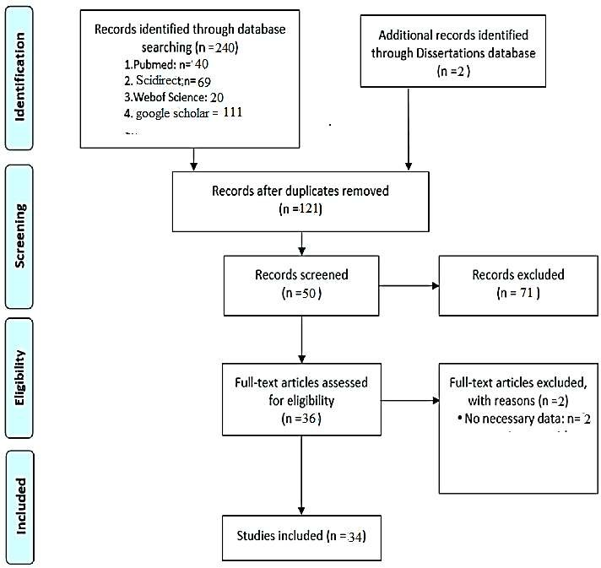
Figure 2. Flowchart for Selection of Relevant Literature for the Review.

Short title of article should not be more than 60 characters (including space) Short Author

Table 1. Tables should their Captions.
Scientific Name | Part Used | Publication Year | Analytical Method | Constituents | Reference
Piper longum Linn | Fruit | 2006 | RP-HPLC | Sesamin, brachystamide guineensine | [8]
Woodfordia fruticosa | Flower | 2014 | TLC Fingerprint, Fluorescence | Ellagic acid, gallic acid | [9]
Dioscorea bulbifera | Whole | 2013 | AAS, UV | Vit C, Vit D | [10]
Cucurbita maxima | Seed | 2012 | TLC, HPTLC, GC/MS | Glucaosazone | [11]
Aerva lanata | Whole | 2014 | FT-IR |  | [12]
Curcuma caesia | Leaf | 2017 | GC MS, FT-IR | α-Santalol, Retinal, Ar- tumerone | [13]
Boswellia serrate | Leaf | 2012 | TLC, IR, GC/MS, NMR | Tetrahydro-2H-pyran-2, 3, 4, 5-tetrol | [14]
Aloe vera | Stem | 2012 | HPTLC Fingerprint | Berberine, gallic acid | [15]

Table 2. Fluorescence Study of Selected Medicinal Plants.
Study | Scientific Name | Part Used | Reagent Used | Reference
Physicochemical properties | Butea frondosa Koen. | Leaf | H2SO4, HNO3, NaOH, FeCl3 and picric acid | [16]
>> | Woodfordia fruticosa | Flower | NaOH, HCl and H2SO4 | [17]
>> | Cajanus scarabaeoides | Whole | NaOH, HCl, H2SO4, HNO3 and KOH | [18]

2016-2020

2010-2015

< 2010 

0 2 4 6 8 10 12 14 16 18

 | < 2010 | 2010-2015 | 2016-2020
number of publication | 1 | 17 | 16

Figure 2. Summary of Studies Included in the Review (n=34) by Year of Publication.

CONCLUSION
The conclusions section should come in this section at the end of the article, before the acknowledgements.

Declaration of Interest
Authors should reveal any possible conflict of interest in their submitted manuscripts. A competing interest exists when professional judgment concerning the validity of work is influenced by a secondary interest, such as financial gain. The author(s) declare(s) that there is no conflict of interest regarding the publication of this manuscript.

Title of the STM Journals Volume 10, Issue 1
ISSN: 2278-2257 (Online), ISSN: 2348-9553 (Print)

Acknowledgement
The acknowledgements come at the end of an article after the conclusions and before the notes and references.

REFERENCES
References (reference have been arranged as per Author-Number System) (at least 10 references and not more than 50 references; also, recent references should be included.).

All References mentioned in the reference list are cited in the text and vice versa. In reference list, each reference should have at least name of author, title of the article, place of publication (name of book or journal), and year of publication. All References mentioned in the reference list are cited in the text and vice versa. In reference list, each reference should have at least name of author, title of the article, place of publication (name of book or journal), and year of publication. All References mentioned in the reference list are cited in the text and vice versa. In reference list, each reference should have at least name of author, title of the article, place of publication (name of book or journal), and year of publication.

Author(s). Title of article. Title of journal. Publication year; Volume(Issue): Pages. (JOURNAL)
- Skalsky K, Yahav D, Bishara. J Treatment of human brucellosis: Systematic review and meta-analysis of randomised controlled trials. BMJ. 2008; 336(7646): 701–4p. (Journal)
- O’Leary C. Vitamin C does little to prevent winter cold. The West Australian. Forthcoming 2005 Can include date, volume and issue number if provided (JOURNAL ARTICLE IN PRESS)
- Fletcher D, Wagstaff CRD. Organisational psychology in elite sport: its emergence, application and future. Psychol Sport Exerc. 2009;10(4):427–34p. doi:10.1016/j.psychsport.2009.03.009. (ELECTRONIC ARTICLE WITH DOI NUMBER)

Author(s). Multiple authors separated by a comma. Title of Book. Edition of book if later than 1st edition. Place of Publication: Publisher Name; Year of Publication. (BOOKS)
- Hofmeyr GJ, Neilson JP, Alfirevic Z, et al. A Cochrane Pocketbook: Pregnancy and Childbirth. Chichester, West Sussex, England: John Wiley & Sons Ltd; 2008. (REFERENCE TO A BOOK)
- Rowlands TE, Haine LS. Acute limb ischaemia. In: Donnelly R, London NJM, (editors). ABC of Arterial and Venous Disease. 2nd edition. West Sussex: Blackwell Publishing; 2009. (REFERENCE TO A CHAPTER IN AN EDITED BOOK)
- Bartlett A, Breastwork: Rethinking breastfeeding [monograph online]. Sydney, NSW: University of New South Wales Press; 2005. Available from: Net Library (ELECTRONIC BOOK)

Author(s). Title of paper. In: Editor(s). editor(s). Title of Conference; Date of conference; Place of conference. Place of publication: Publisher’s name; Year of publication. Page numbers. (CONFERENCE PAPERS)
- Kimura J, Shibasaki H (editors). Recent advances in clinical neurophysiology. Proceedings of the 10th International Congress of EMG and Clinical Neurophysiology; 1995 Oct 15-19; Kyoto, Japan. Amsterdam: Elsevier; 1996. (CONFERENCE PROCEEDINGS)
- Bengtsson S, Solheim BG. Enforcement of data protection, privacy and security in medical informatics. In: Lun KC. Degoulet P. Piemme TE, Reinhoff O, (editors) MEDINFO 92. Proceedings of the 7th World Congress on Medical Informatics; 1992 Sep 6-10; Geneva, Switzerland. Amsterdam: North Holland; 1992. 1561–5. (PUBLISHED CONFERENCE PAPER)

Short title of article should not be more than 60 characters (including space) Short Author

- Bowden FJ, Fairley CK. Endemic STDs in the Northern Territory: Estimations of effective rates of partner exchange. Paper presented at: The Scientific Meeting of the Royal Australian College of Physicians. Darwin, Australia. 1996 June 24-25. (UNPUBLISHED CONFERENCE PAPER)

Author(s). Article title. Newspaper title (edition of paper e.g., Weekend edition). Date of publication – year month day: Sect. Location e.g. A:12 or Business 5 (5 is the page number) column number is applicable e.g., col. 1) (NEWSPAPER AND MAGAZINE ARTICLES)
- Robertson J. Not married to the art. The Courier Mail (Weekend Edition). 2010 Mar 6- 7:Sect. ETC:15 (NEWSPAPER ARTICLE)
- Marano HE. Making of a perfectionist. Psychol Today. 2008 Mar-Apr;41:80-86
(MAGAZINE ARTICLE)
- Bajak F. Why Chile dodged Haiti-style ruin. Toronto Star (Canada) [serial online]. 2010 Feb 28 [cited 2010 Mar 14]; Sect. News: A14 Available from: Australia/New Zealand Reference Centre (ELECTRONIC NEWSPAPER OR MAGAZINE ARTICLE)
- Drivers told: Don’t use Clem7 tunnel. The Courier Mail [Internet]. 2010 Mar 16 [cited 2010 Mar 16]; Available from: http://www.couriermail.com.au/news/car-with-flat-tyre-the-first- to-cause-problems-in-clem7-tunnel/story-e6freon6-1225841179464 (ELECTRONIC NEWSPAPER ARTICLE ON THE INTERNET)

Author(s). Title of report. Place of publication: Publisher; Date of publication – year month if applicable. Total number of pages if applicable, e.g., 24 p. Report No.: (if applicable) (REPORTS AND OTHER GOVERNMENT PUBLICATIONS)
- Australia. Parliament. Senate. Select Committee on Climate Policy. Climate Policy Report. Canberra: The Senate; 2009. (REPORTS AND OTHER GOVERNMENT PUBLICATIONS)
- Page E, Harney JM. Health Hazard Evaluation Report. Cincinnati (OH): National Institute for Occupational Safety and Health (US); 2001 Feb. 24 p. Report No.: HETA2000-0139- 2824. (REPORTS AND OTHER GOVERNMENT PUBLICATIONS)

Title of the Journals Pub
http://journalspub.com/list-of-journals.html
ISSN: 2581-9062
Volume 4, Issue 1, 2021
DOI (Journal): 10.37628/ABBREV

Type of Article ABBREVIATION

Title of the Article

First Author Full Name^{1,*}, Second Author Full Name², Third Author Full Name¹, Fourth Author Full Name³

Abstract
An abstract is a brief summary of a main manuscript. It should be written in ~300 words. The abstract should be written concisely and clearly without any abbreviations, references, or citation. The abstract should be well written and is grammatically correct.

Keywords: There should be five to ten keywords or phrases each separated by a comma

INTRODUCTION
Manuscript should be submitted in .doc, .docx, .rtf files. Manuscript should be around 2000 to 7000 word count [1]. Please do not use MS Word older than the 2010 version. Use only Microsoft Office 2010 or later versions. The main text of the manuscript should appear here with headings as appropriate. Author should mention the type of manuscript on the top of manuscript (research article, review article, case study, popular article, or any other type of article).

Authorship should be carefully listed in a correct order of authors before submitting the manuscript. Author can made addition, deletion, or rearrangement of author names in the authorship list only before the manuscript has been accepted.

Introduce the article properly in paragraphs separated by headings, subheadings, images, and formulae. To avoid errors in the article, author is advised to use the ‘spellchecker’ function of MS Word. Authors are responsible for obtaining permission from copyright holders for reproducing any illustrations, tables, figures, or lengthy quotations previously published elsewhere.

Article should be written in following order: Title of the Article, Authors, Affiliations, Abstract, Keywords, Main text (including figures and tables), Conflicts of Interest, Ethics Approval,
Acknowledgements, Abbreviations and Nomenclature, References, Appendix. Author should not use
footnote or endnote for the citation in the article.

HIERARCHY OR LEVEL OF HEADING
*Author for Correspondence
Corresponding Author Full Name
E-mail: baedfcvbgsayana@gmail.com

¹Affiliation and complete postal addresses of affiliated organization all authors (e.g., Affiliation, Name of Affiliated Organization, Name of Department/School/Faculty/Research Group, Name of University/Institution/College, City, State/Province, Country)
²Lecturer, Department of Pharmacy, College of Medical and Health Science, Bule Hora University, Bule Hora, Ethiopia ³Assistant Lecturer, Department of Veterinary Pharmacy, Gondar University, Gondar, Ethiopia

Received Date: Month Date, Year Accepted Date: Month Date, Year Published Date: Month Date, Year

Citation: First Author, Second Author, Third Author, Fourth Author. Title of Article. Title of the Journals Pub. Year; volume(issue): 1–5p.
Author can use headings, subheadings to present the work in the following ways.

LEVEL 1 OR H1 HEADING: PHILOSOPHICAL APPROACHES
Bryman [2] asserts that there are different views about the scope, range, ordering, and labelling of philosophical approaches.

Level 2 or H2 Heading: Philosophical Approaches
Bryman [3] asserts that there are different views about the scope, range, ordering, and labelling of philosophical approaches.

Short title of article should not be more than 60 characters (including space) Short Author

Level 3 or H3 Heading: Philosophical Approaches
Bryman [4] asserts that there are different views about the scope, range, ordering, and labelling of philosophical approaches.

Level 4 or H4 Heading: Philosophical Approaches
Bryman [5] asserts that there are different views about the scope, range, ordering, and labelling of philosophical approaches.

Level 5 or H5 Heading: Philosophical approaches (H5): Bryman [6] asserts that there are different views about the scope, range, ordering, and labelling of philosophical approaches.

Level 6 or H6 Heading: Philosophical approaches: Bryman [7] asserts that there are different views about the scope, range, ordering, and labelling of philosophical approaches.

TABLES AND FIGURES
Authors should submit tables as editable text and not as images. Tables should be numbered (with Arabic numerals as Table 1, Table 2, etc.) and referred to by number in the text. Tables can be placed either next to the relevant text in the article, or on separate page(s) at the end. The captions for the Tables should be provided separated from the text. All Figures and Tables should be numbered and cited. Source of all Figures should be provided.

For all Tables, use the following symbols in order as footnotes: * (asterisk), † (dagger), ‡ (double
dagger), ¶ (paragraph mark), § (section mark), ‖ (parallels), **, ††, ‡‡, etc.

Authors should submit Figures as per “Artwork Guidelines”. Figures are to be numbered in one consecutive series of Arabic numerals in the order in which they are cited in the text. The captions for illustrations and figures should be separated from the text and collated in a separate section called “Legend to Figures.” Tables and Figures should be self-explanatory.
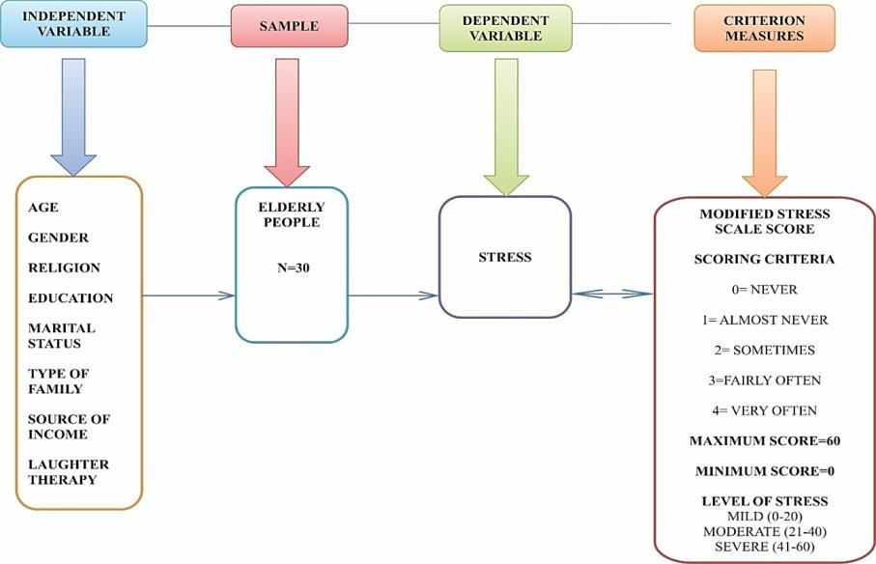
Figure 1. Figures should their Captions.

Artwork Guidelines
Illustrations, pictures, and graphs should be with the highest quality, and text in the illustrations, pictures and graphs should be readable. Following guidelines enable us to prepare your artwork for the printed issue as well as the online version.

Title of the Journals Pub Volume 4, Issue 1
ISSN: 2581-9062

Placement: Figures/charts and tables created in MS Word should be included in the main text. Figures and other files created outside Word (i.e., Excel, PowerPoint, JPG, TIFF, EPS, and PDF) should be submitted separately. Please add a callout in the running text (i.e., insert Figure 1).

Resolution: Rasterized based files (i.e., with .tiff or .jpeg extension) require a resolution of at least 300 dpi (dots per inch). Line art should be supplied with a minimum resolution of 800 dpi.

UNITS OF MEASUREMENT
Authors should follow internationally accepted rules and conventions. Units should be expressed in the international system of units (SI). If other units are mentioned, please give their equivalent in SI.

ABBREVIATIONS AND NOMENCLATURE
Except for units of measurement, abbreviations, and nomenclature when it appears for the first time should be spelled out for the first time.

MATH FORMULAE
Math equations should be presented as editable text and not as images. Simple formulae should be in line with normal text where possible. Use the solidus (/) instead of a horizontal line for small fractional terms, e.g., X/Y. Equations should be numbered consecutively in Arabic numerals if referred explicitly in the text.
Figure 2. Flowchart for Selection of Relevant Literature for the Review.

Short title of article should not be more than 60 characters (including space) Short Author

Table 1. Tables should their Captions.
Scientific Name | Part Used | Publication Year | Analytical Method | Constituents | Reference
Piper longum Linn | Fruit | 2006 | RP-HPLC | Sesamin, brachystamide guineensine | [8]
Woodfordia fruticosa | Flower | 2014 | TLC Fingerprint, Fluorescence | Ellagic acid, gallic acid | [9]
Dioscorea bulbifera | Whole | 2013 | AAS, UV | Vit C, Vit D | [10]
Cucurbita maxima | Seed | 2012 | TLC, HPTLC, GC/MS | Glucaosazone | [11]
Aerva lanata | Whole | 2014 | FT-IR |  | [12]
Curcuma caesia | Leaf | 2017 | GC MS, FT-IR | α-Santalol, Retinal, Ar- tumerone | [13]
Boswellia serrate | Leaf | 2012 | TLC, IR, GC/MS, NMR | Tetrahydro-2H-pyran-2, 3, 4, 5-tetrol | [14]
Aloe vera | Stem | 2012 | HPTLC Fingerprint | Berberine, gallic acid | [15]

Table 1. Mean and Standard and t-Value of Pre-Test and post-Test Level of Stress among Elderly People (N=30).
Level of Stress | Mean | SD | t-Value
Pre-test | 35.6 | 11.8 | 11.4*
Post-test | 26.9 | 10.7 | 11.4*
Maximum Score= 60*= Significant (p>0.05) Minimum Score= 0.

Pre test Post test
70.00%
63%
43%
43%
30%
13.00%
7%

60.00%

50.00%

40.00%

30.00%

20.00%

10.00%

0.00%
Mild Moderate Severe

Figure 3. Comparison between Pre-Test and Post-Test Level of Stress among Elderly People.

CONCLUSION
The conclusions section should come in this section at the end of the article, before the acknowledgements.

Declaration of Interest
Authors should reveal any possible conflict of interest in their submitted manuscripts. A competing interest exists when professional judgment concerning the validity of work is influenced by a secondary interest, such as financial gain. The author(s) declare(s) that there is no conflict of interest regarding the publication of this manuscript.

Title of the Journals Pub Volume 4, Issue 1
ISSN: 2581-9062

Acknowledgement
The acknowledgements come at the end of an article after the conclusions and before the notes and references.

REFERENCES
References (reference have been arranged as per Author-Number System) (at least 10 references and not more than 50 references; also, recent references should be included.).

All References mentioned in the reference list are cited in the text and vice versa. In reference list, each reference should have at least name of author, title of the article, place of publication (name of book or journal), and year of publication. All References mentioned in the reference list are cited in the text and vice versa. In reference list, each reference should have at least name of author, title of the article, place of publication (name of book or journal), and year of publication. All References mentioned in the reference list are cited in the text and vice versa. In reference list, each reference should have at least name of author, title of the article, place of publication (name of book or journal), and year of publication.

Author(s). Title of article. Title of journal. Publication year; Volume(Issue): Pages. (JOURNAL)
- Skalsky K, Yahav D, Bishara. J Treatment of human brucellosis: Systematic review and meta-analysis of randomised controlled trials. BMJ. 2008; 336(7646): 701–4p. (Journal)
- O’Leary C. Vitamin C does little to prevent winter cold. The West Australian. Forthcoming 2005 Can include date, volume and issue number if provided (JOURNAL ARTICLE IN PRESS)
- Fletcher D, Wagstaff CRD. Organisational psychology in elite sport: its emergence, application and future. Psychol Sport Exerc. 2009;10(4):427–34p. doi:10.1016/j.psychsport.2009.03.009. (ELECTRONIC ARTICLE WITH DOI NUMBER)

Author(s). Multiple authors separated by a comma. Title of Book. Edition of book if later than 1st edition. Place of Publication: Publisher Name; Year of Publication. (BOOKS)
- Hofmeyr GJ, Neilson JP, Alfirevic Z, et al. A Cochrane Pocketbook: Pregnancy and Childbirth. Chichester, West Sussex, England: John Wiley & Sons Ltd; 2008. (REFERENCE TO A BOOK)
- Rowlands TE, Haine LS. Acute limb ischaemia. In: Donnelly R, London NJM, (editors). ABC of Arterial and Venous Disease. 2nd edition. West Sussex: Blackwell Publishing; 2009. (REFERENCE TO A CHAPTER IN AN EDITED BOOK)
- Bartlett A, Breastwork: Rethinking breastfeeding [monograph online]. Sydney, NSW: University of New South Wales Press; 2005. Available from: Net Library (ELECTRONIC BOOK)

Author(s). Title of paper. In: Editor(s). editor(s). Title of Conference; Date of conference; Place of conference. Place of publication: Publisher’s name; Year of publication. Page numbers. (CONFERENCE PAPERS)
- Kimura J, Shibasaki H (editors). Recent advances in clinical neurophysiology. Proceedings of the 10th International Congress of EMG and Clinical Neurophysiology; 1995 Oct 15-19; Kyoto, Japan. Amsterdam: Elsevier; 1996. (CONFERENCE PROCEEDINGS)
- Bengtsson S, Solheim BG. Enforcement of data protection, privacy and security in medical informatics. In: Lun KC. Degoulet P. Piemme TE, Reinhoff O, (editors) MEDINFO 92. Proceedings of the 7th World Congress on Medical Informatics; 1992 Sep 6-10; Geneva, Switzerland. Amsterdam: North Holland; 1992. 1561–5. (PUBLISHED CONFERENCE PAPER)

Short title of article should not be more than 60 characters (including space) Short Author

- Bowden FJ, Fairley CK. Endemic STDs in the Northern Territory: Estimations of effective rates of partner exchange. Paper presented at: The Scientific Meeting of the Royal Australian College of Physicians. Darwin, Australia. 1996 June 24-25. (UNPUBLISHED CONFERENCE PAPER)

Author(s). Article title. Newspaper title (edition of paper e.g., Weekend edition). Date of publication – year month day: Sect. Location e.g. A:12 or Business 5 (5 is the page number) column number is applicable e.g., col. 1) (NEWSPAPER AND MAGAZINE ARTICLES)
- Robertson J. Not married to the art. The Courier Mail (Weekend Edition). 2010 Mar 6- 7:Sect. ETC:15 (NEWSPAPER ARTICLE)
- Marano HE. Making of a perfectionist. Psychol Today. 2008 Mar-Apr;41:80-86
(MAGAZINE ARTICLE)
- Bajak F. Why Chile dodged Haiti-style ruin. Toronto Star (Canada) [serial online]. 2010 Feb 28 [cited 2010 Mar 14]; Sect. News: A14 Available from: Australia/New Zealand Reference Centre (ELECTRONIC NEWSPAPER OR MAGAZINE ARTICLE)
- Drivers told: Don’t use Clem7 tunnel. The Courier Mail [Internet]. 2010 Mar 16 [cited 2010 Mar 16]; Available from: http://www.couriermail.com.au/news/car-with-flat-tyre-the-first- to-cause-problems-in-clem7-tunnel/story-e6freon6-1225841179464 (ELECTRONIC NEWSPAPER ARTICLE ON THE INTERNET)

Author(s). Title of report. Place of publication: Publisher; Date of publication – year month if applicable. Total number of pages if applicable, e.g., 24 p. Report No.: (if applicable) (REPORTS AND OTHER GOVERNMENT PUBLICATIONS)
- Australia. Parliament. Senate. Select Committee on Climate Policy. Climate Policy Report. Canberra: The Senate; 2009. (REPORTS AND OTHER GOVERNMENT PUBLICATIONS)
- Page E, Harney JM. Health Hazard Evaluation Report. Cincinnati (OH): National Institute for Occupational Safety and Health (US); 2001 Feb. 24 p. Report No.: HETA2000-0139- 2824. (REPORTS AND OTHER GOVERNMENT PUBLICATIONS)

